Deep Learning Lab Assignment-2

Name: Saketh Garuda

ID: 16

## Introduction:

This lab assignment helps in learning about the working of tensor flow and implementation of text classification with CNN model using python. Visualization charts and graphs are created and displayed in tensor board.

## Objective:

The main objective for this lab assignment is to know the

* Implementation of text classification with CNN model
* Creating visualization graphs using tensor board
* To change the hyper parameters such as learning rate and get the results

## Configuration:

* PyCharm IDE
* Python 3.6.4
* TensorFlow

## Approaches/Methods:

The CNN model is implemented using python libraries 3.6, tensorflow and visualization graphs are created using tensor board.

## Workflow:

The workflow for the entire model is as follows,

* Loading dataset using import library modules
* Processing data
* Performing CNN operations on data
* Calculating loss and predicting accuracy
* Using session graph for creating visualization graphs in tensorboard.

## Dataset:

Consumer complaints dataset is used in this exercise, which consists of 11 classes.

## Parameters:

The parameters to be considered while constructing the model are,

* Number of epochs
* Batch Size
* Embedding dimensions
* Size of filter
* Probability check

## Evaluation and Discussion:

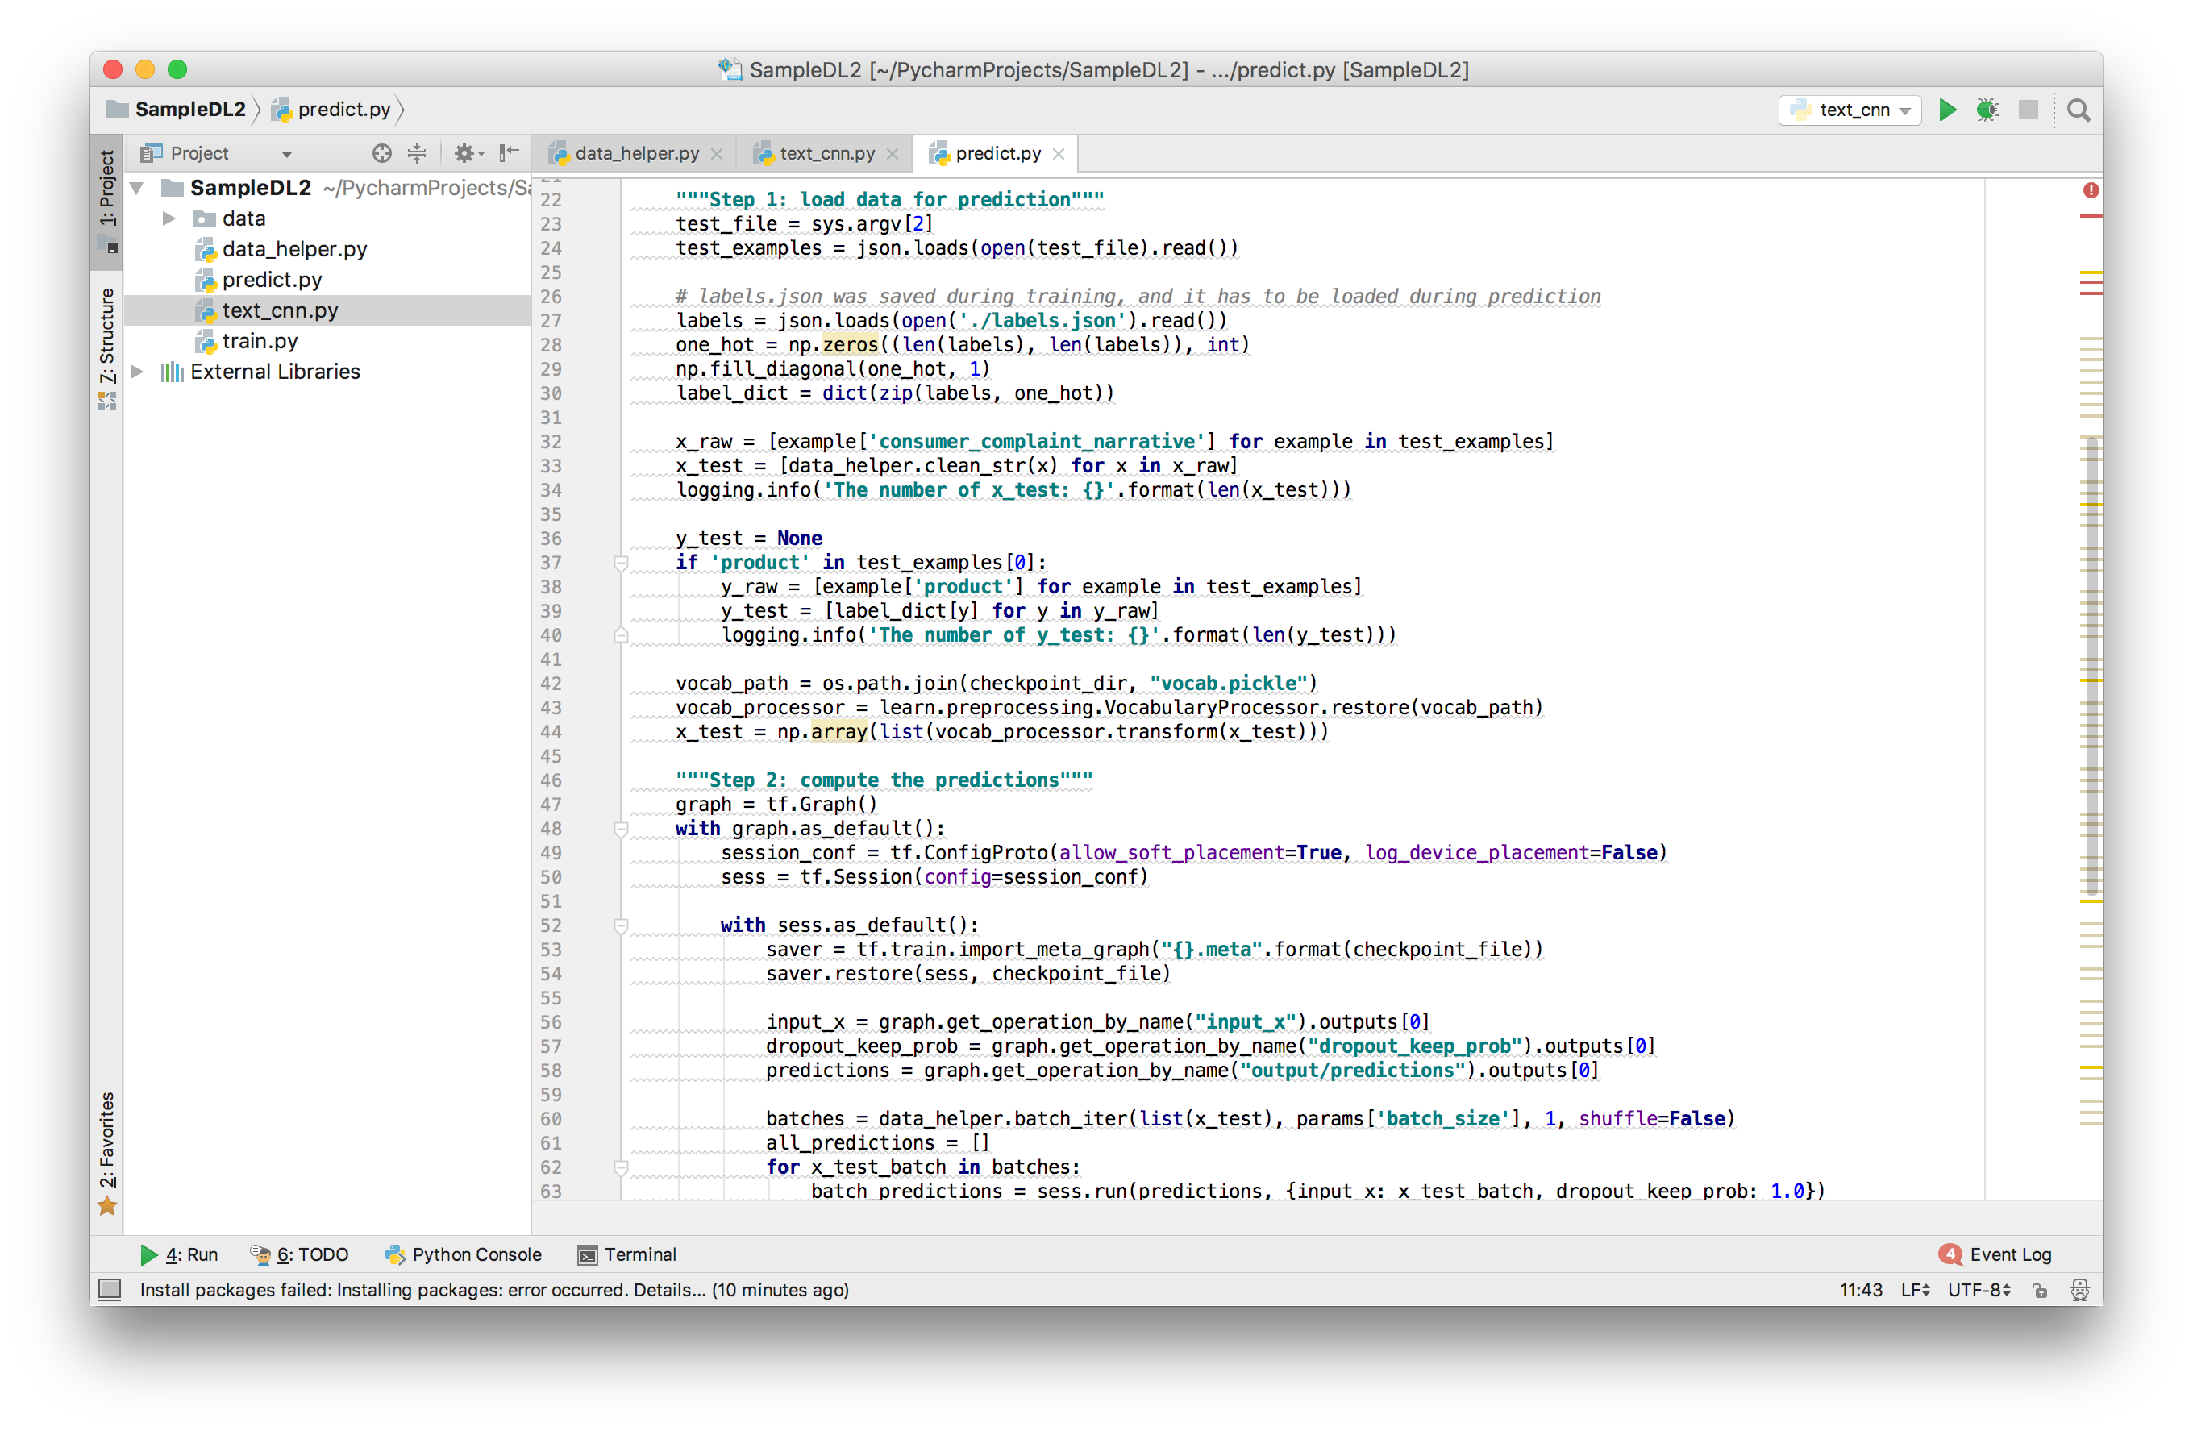

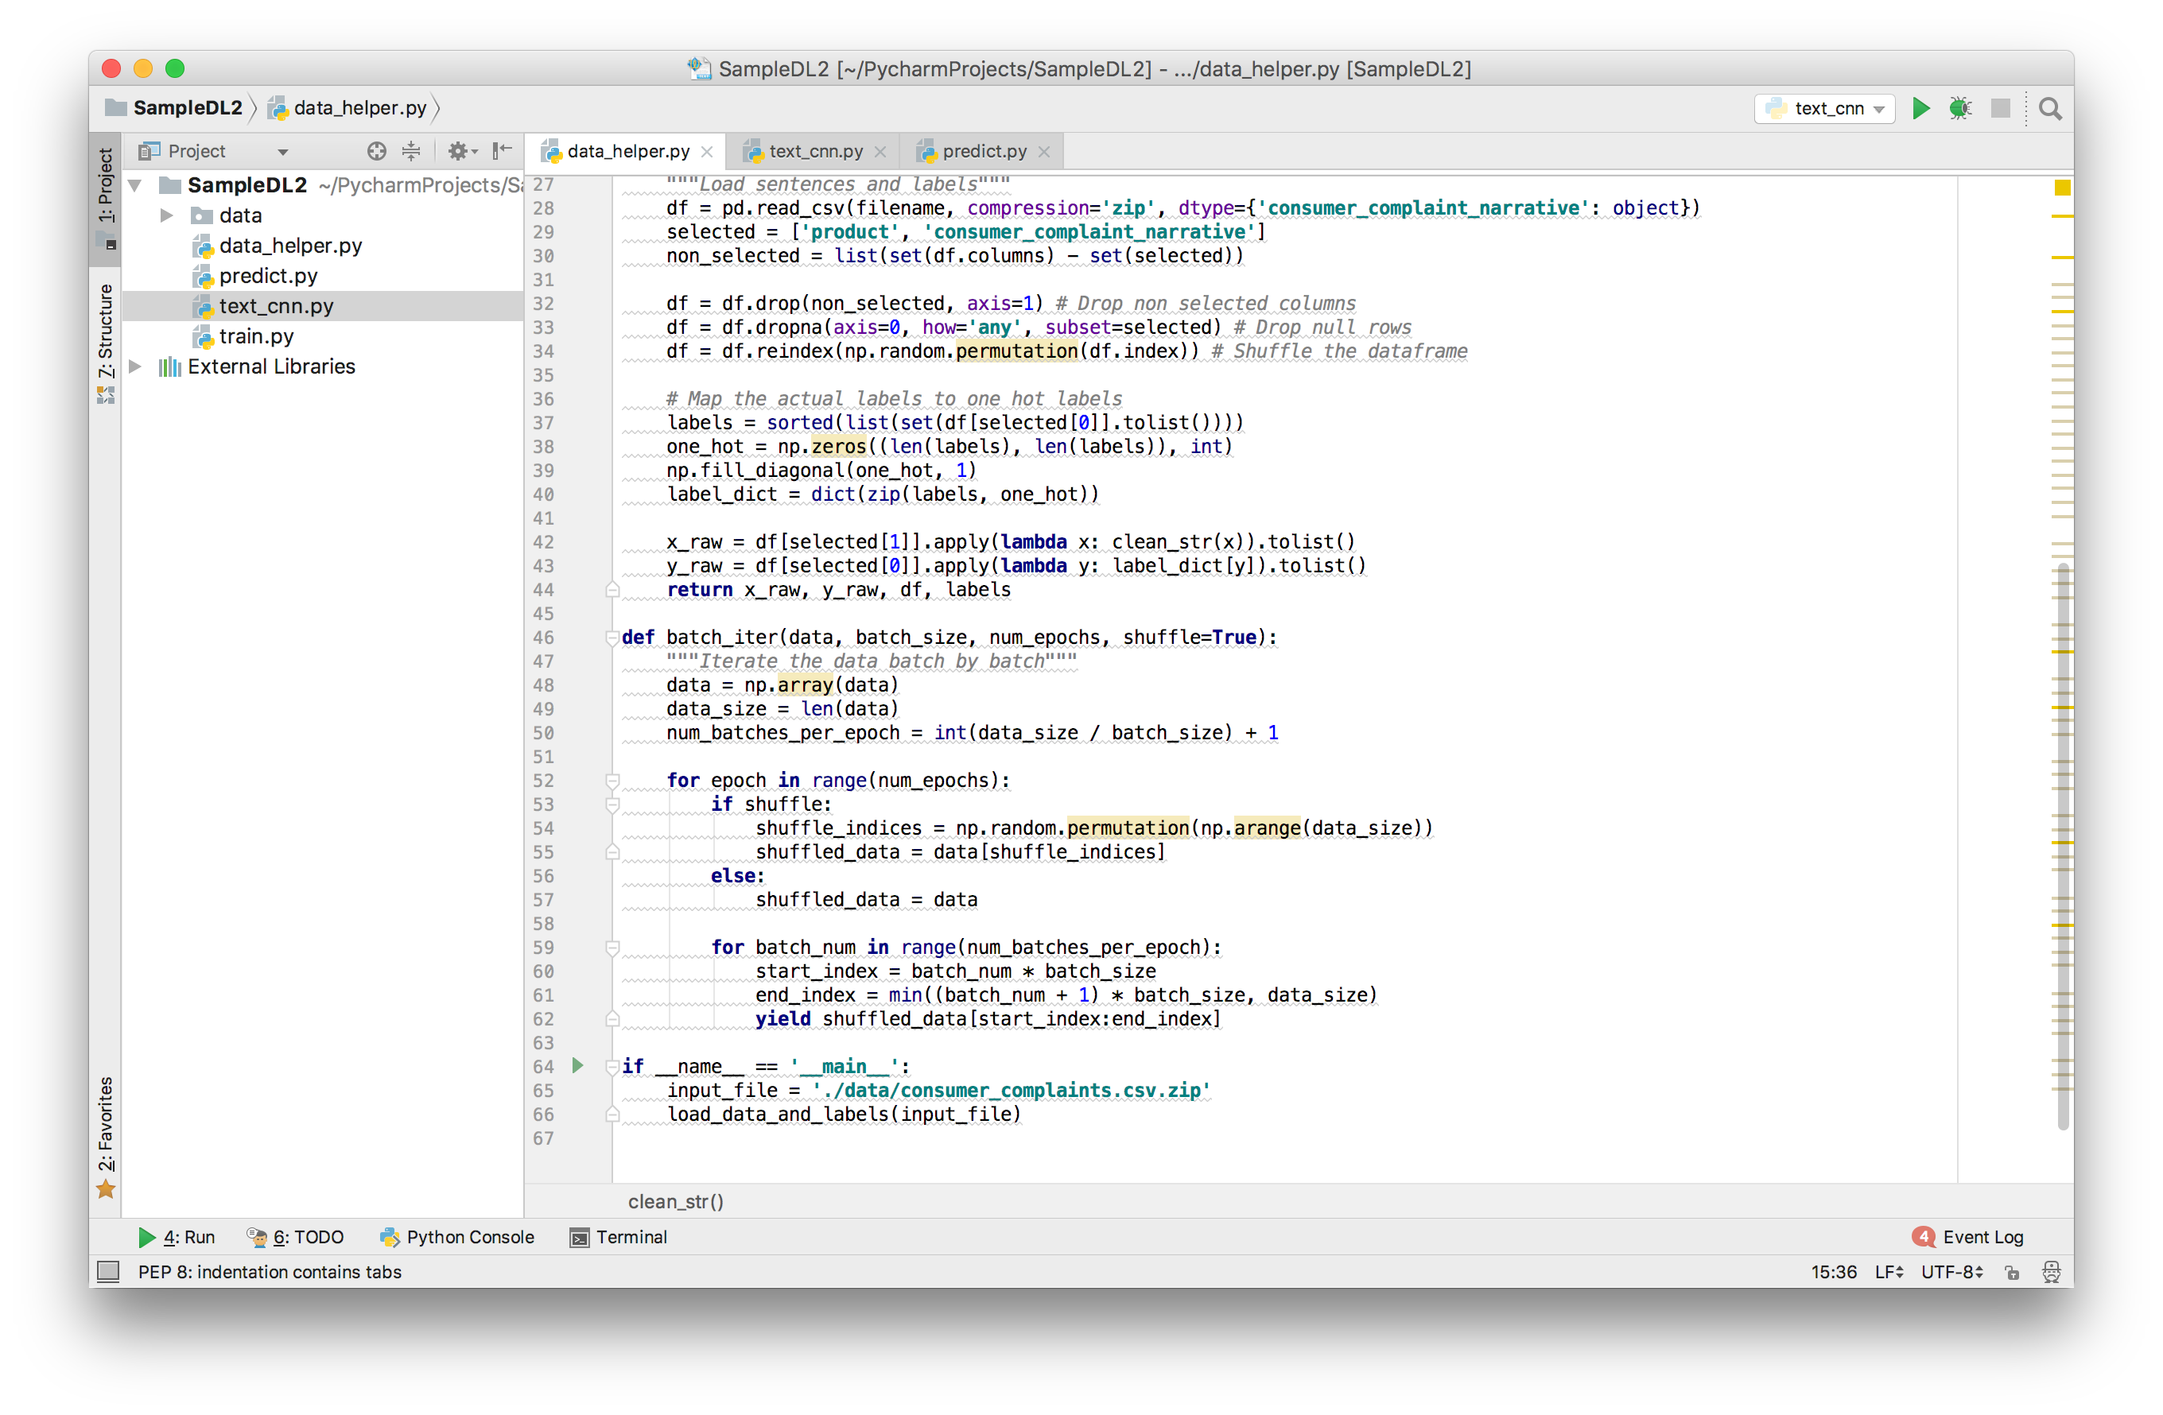

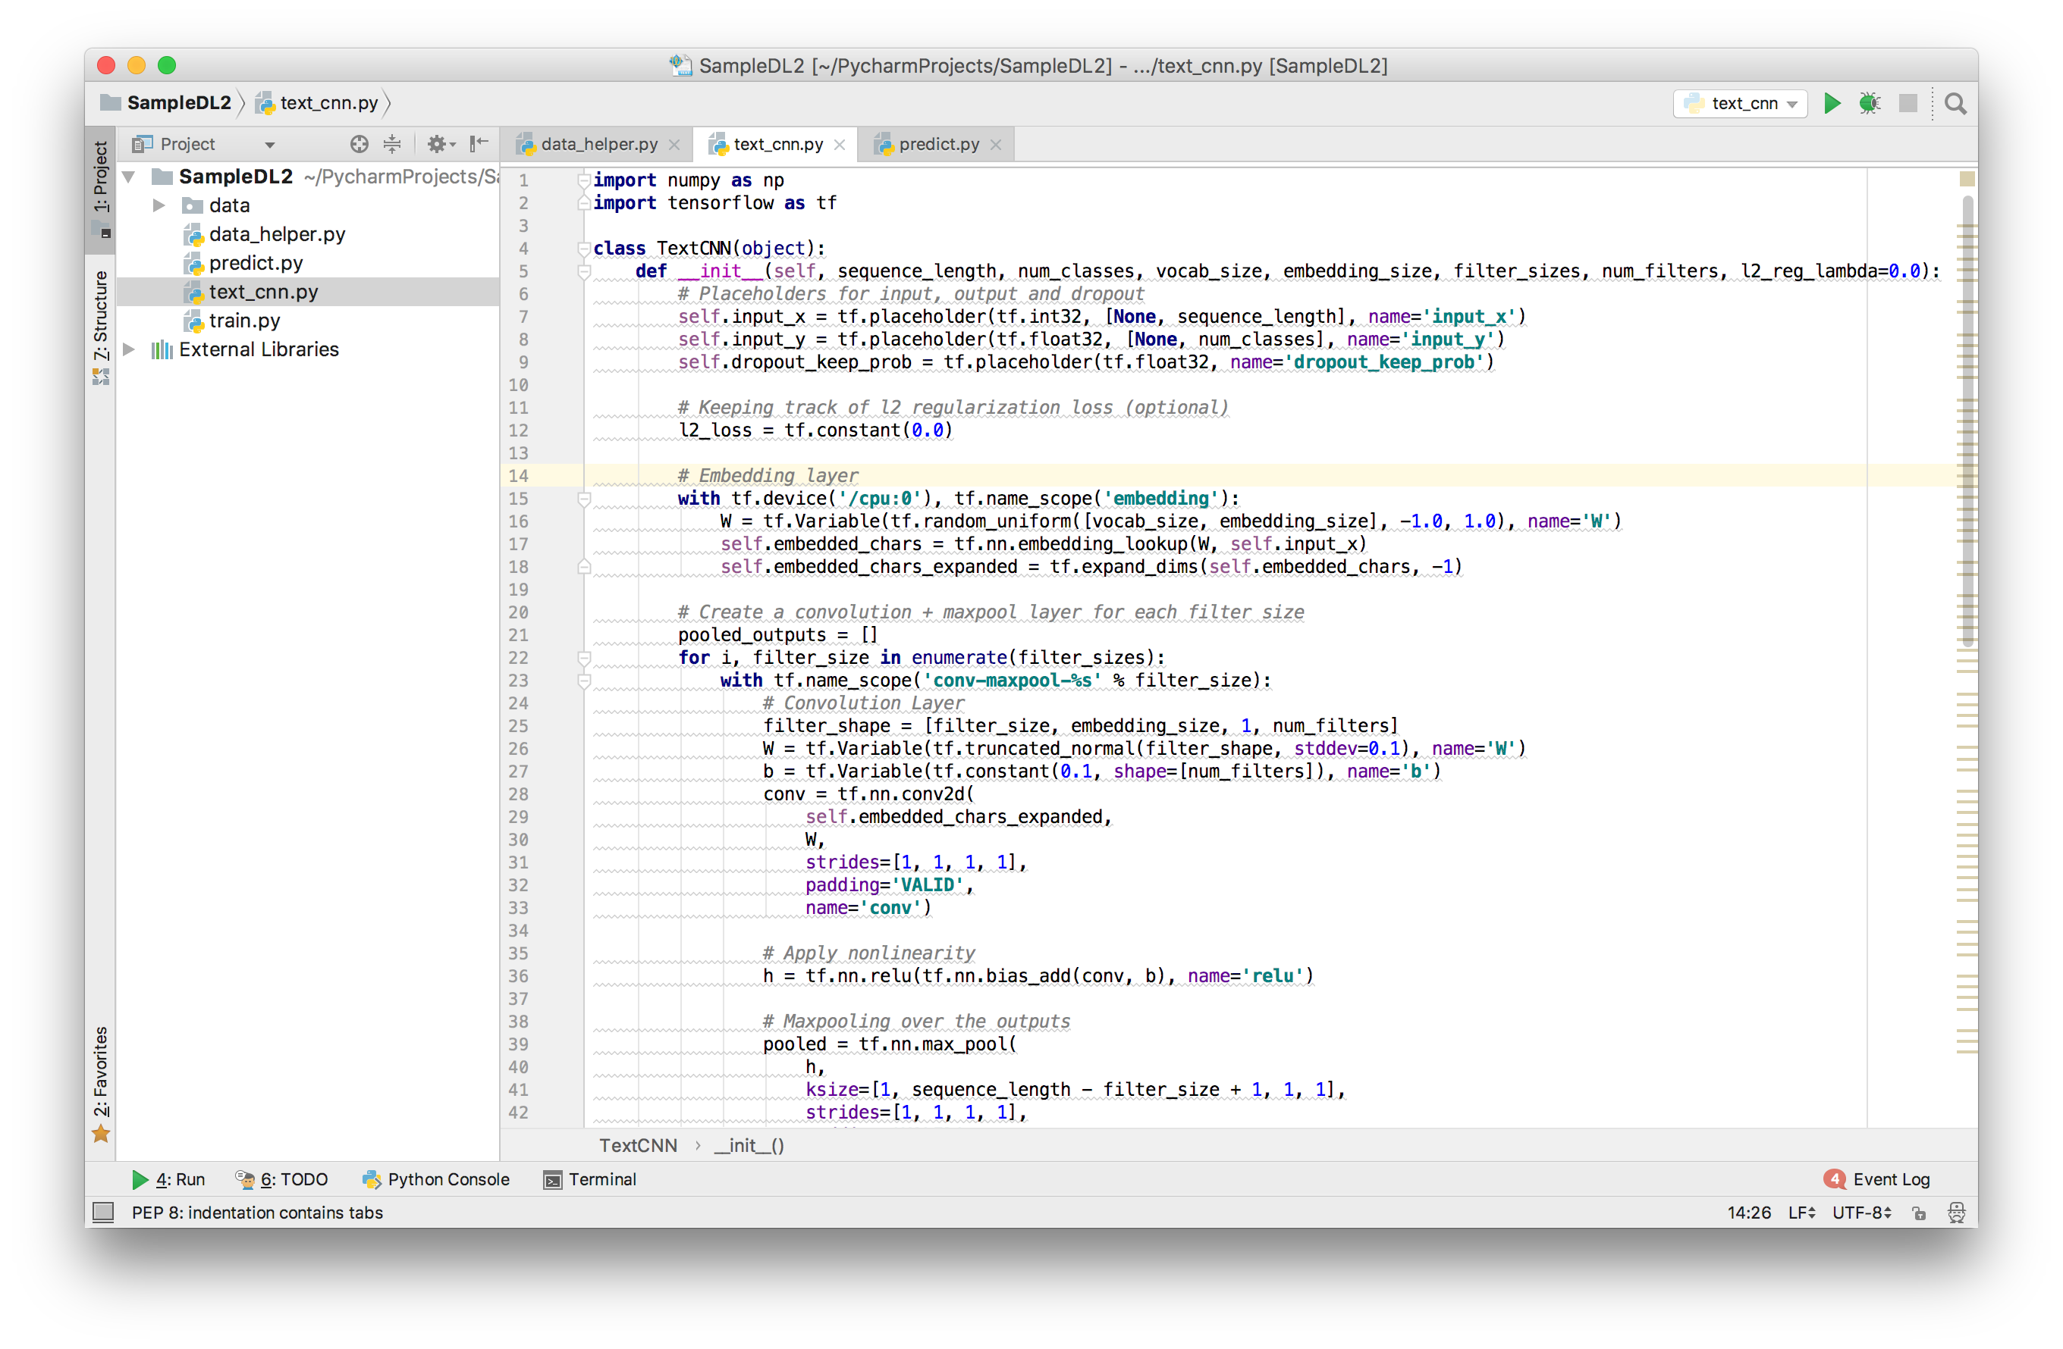

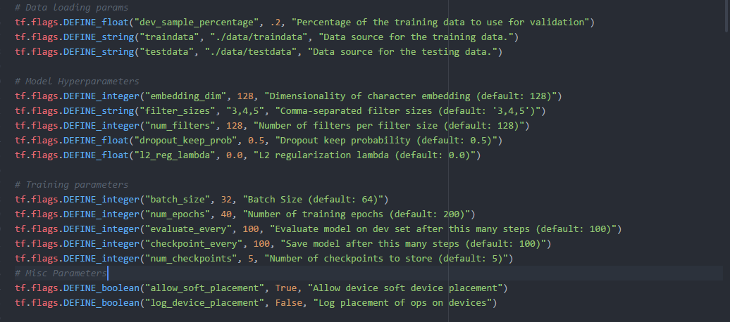

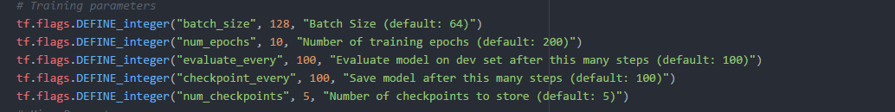

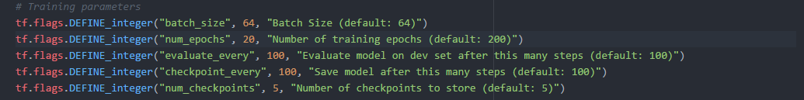

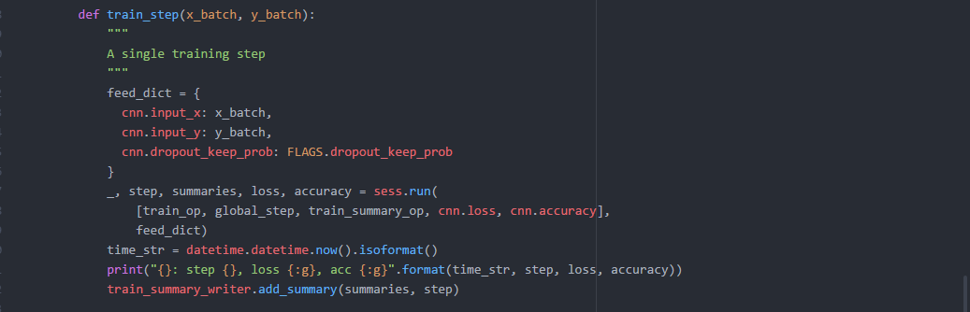

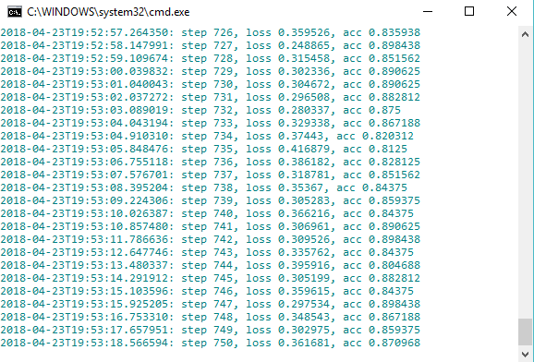

When we change the hyper parameters the as decrease in intervals and increase in batch size then the accuracy decreases accordingly and vice versa. Increasing the batch size to larger number can increase accuracy to greater scale.

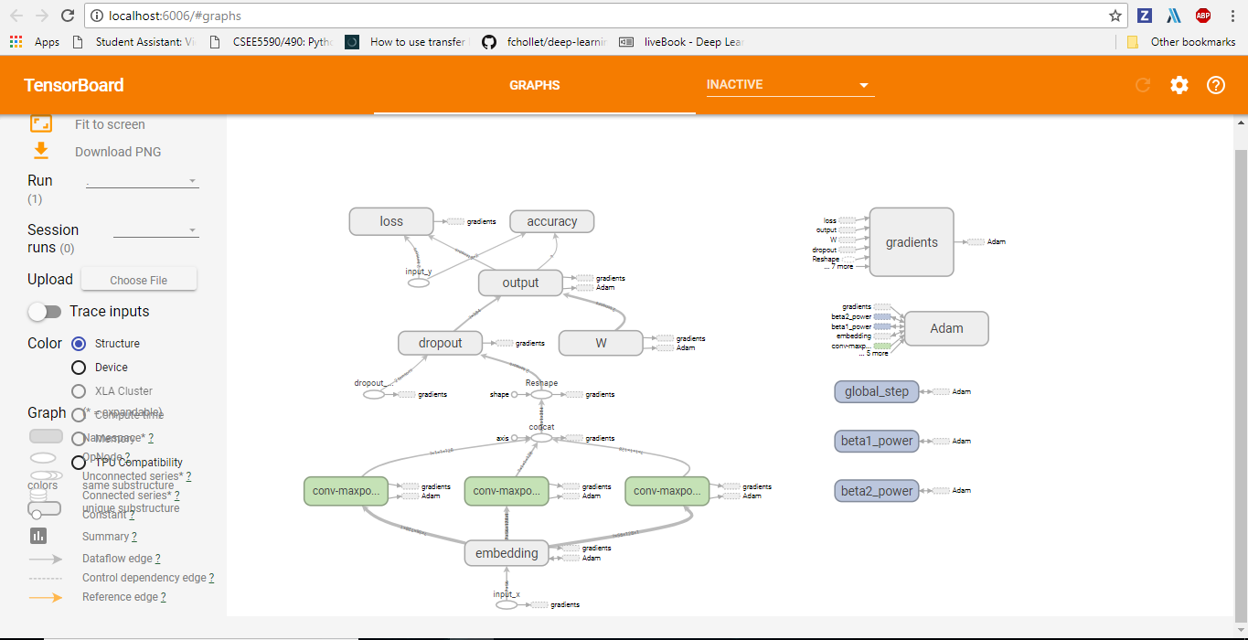

## References:

* <https://www.tensorflow.org/tutorials/wide>
* <https://www.kaggle.com/cfpb/us-consumer-finance-complaints>
* <https://github.com/jiegzhan/multi-class-text-classification-cnn>